Task No: 12 A Date:27/10/25 | Retrieve Analytic Information given from MongoDB  - For each “place_type”, Find total favorite_count  - For each "country_code", find total "retweet_count" | CO5 K3
AIM:
To Retrieve Analytic Information given from MongoDB, for each Place Type, Country code, retweet count.

PROCEDURE:
- Install pymongo in Pycharm IDE
- Import the pymongo module in the analytics program
- Configure the mongodb server using mongodb compass
- Upload the country dataset in to Mongodb
- Get the MongoDB URI, Database name and Collection Name
- Establish the MongoDB connection using MongoDB URI, Database name and Collection Name
- Aggregation pipeline to calculate the total favorite_count, retweet_count
- Generate the results using aggregate functions.
- Print the results, total favorite_count, retweet_count

PROGRAM:
import pymongo
mongo_uri = "mongodb://localhost:27017/" database_name = "Country" collection_name = "Tweets"
client = pymongo.MongoClient(mongo_uri) db = client[database_name]
collection = db[collection_name]

pipeline = [
{
"$group": {
"_id": "$country_code",
"total_favorite_count": {"$sum": "$favorite_count"}, "total_retweet_count": {"$sum": "$retweet_count"}
}
}
]
result = list(collection.aggregate(pipeline)) if result:
total_favorite_count = result[0]["total_favorite_count"] total_retweet_count = result[1]["total_retweet_count"] print(f"Total favorite_count: {total_favorite_count}") print(f"Total_retweet_count: {total_retweet_count}")
else:

print("No tweets found in the collection.")

# Close the MongoDB connection client.close()

SAMPLE DATASET:
country_code | latitude | longitude | country_name | place_type | favorite_count | retweet_count
AE | 23.424076 | 53.847818 | United Arab  Emirates | Residential | 7 | 4
AE | 23.424076 | 53.847818 | United Arab  Emirates | Commercial | 5 | 2
AR | -38.416097 | -63.616672 | Argentina | Educational | 4 | 6
AR | -38.416097 | -63.616672 | Argentina | Cultural | 5 | 5
IN | 20.593684 | 78.96288 | India | Religious | 80 | 3
IN | 20.593684 | 78.96288 | India | Historical | 100 | 6
TH | 15.870032 | 100.992541 | Thailand | Shopping | 2 | 5
IN | 20.593684 | 78.96288 | India | Sports | 55 | 3
AO | -11.202692 | 17.873887 | Angola | Residential | 2 | 6
AQ | -75.250973 | -0.071389 | Antarctica | Commercial | 4 | 4
AR | -38.416097 | -63.616672 | Argentina | Educational | 5 | 9
AS | -14.270972 | -170.132217 | American  Samoa | Cultural | 3 | 6
BD | 23.684994 | 90.356331 | Bangladesh | Religious | 0 | 4
AU | -25.274398 | 133.775136 | Australia | Historical | 8 | 4
AW | 12.52111 | -69.968338 | Aruba | Shopping | 2 | 8
AZ | 40.143105 | 47.576927 | Azerbaijan | Sports | 4 | 5
EG | 26.820553 | 30.802498 | Egypt | Tourist | 2 | 2
IN | 20.593684 | 78.96288 | India | Tourist | 8 | 5
BD | 23.684994 | 90.356331 | Bangladesh | Religious | 9 | 2
OUTPUT:
Total favorite_count: 3
Total_retweet_count: 6 RESULT:
Thus the program to Retrieve Analytic Information given from MongoDB, for each Place Type, Country code, retweet count was executed successfully.

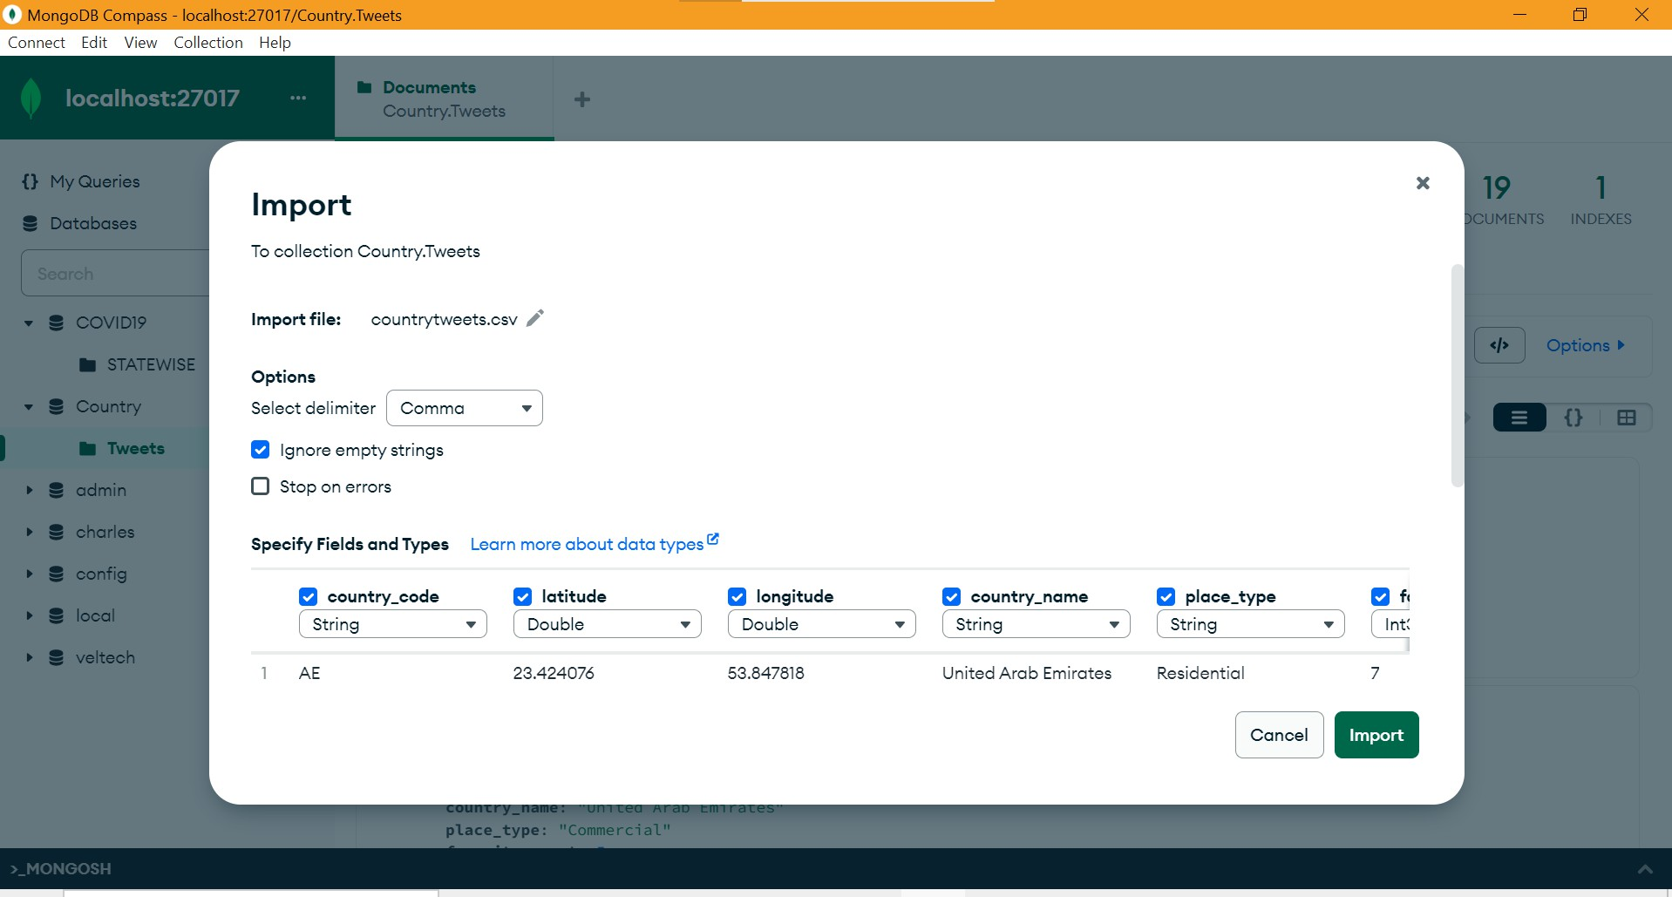

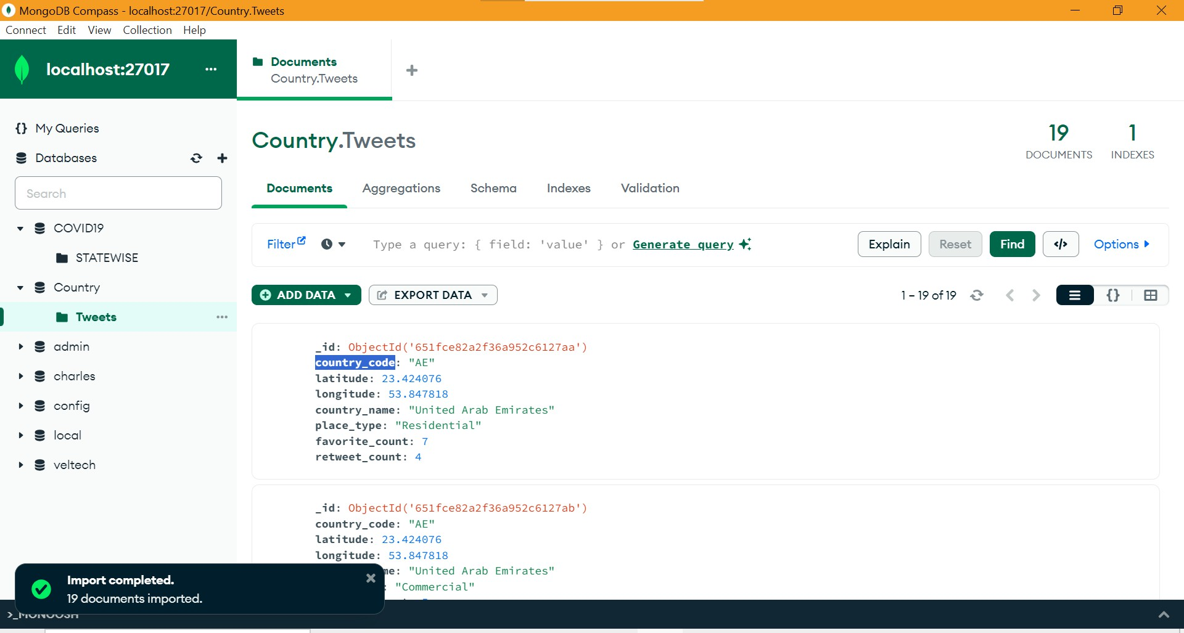

Task No: 12 B Date: | Find out top 10 most frequent topic words of the entire tweet message texts  of your collection after lemmatization/stemming and removing all the Stop Words. | CO5 K3
AIM:
To find the top 10 most frequent topic words of the entire tweet message texts after lemmatization, stemming and removing stop words.

PROCEDURE:
- Install NLTK data in the PyCharm IDE
- Import the NLTK libraries WordNetLemmatizer, PorterStemmer, stopwords
- Read the sample tweet message from Mongodb or assign tweet = „sample message‟
- Tokenize the tweet into words
- Initialize lemmatizer and stemmer
- Lemmatize and stem each word
- Remove stop words
- Define the list of English stop words
- Join the filtered words back into a sentence
- Print the results

PROGRAM:
import nltk
from nltk.stem import WordNetLemmatizer from nltk.stem import PorterStemmer
from nltk.corpus import stopwords

nltk.download('punkt') nltk.download('wordnet') nltk.download('stopwords')
tweet = "The quick brown foxes are jumping over the lazy dogs' bones." words = nltk.word_tokenize(tweet)
lemmatizer = WordNetLemmatizer() stemmer = PorterStemmer()
lemmatized_words = [lemmatizer.lemmatize(word) for word in words] stemmed_words = [stemmer.stem(word) for word in words]
words = nltk.word_tokenize(tweet)

stop_words = set(stopwords.words('english'))
filtered_words = [word for word in words if word.lower() not in stop_words] filtered_text = ' '.join(filtered_words)
print("Original words:", words) print("Lemmatized words:", lemmatized_words)

print("Stemmed words:", stemmed_words) print("Tweet without stop words:", filtered_text)

OUTPUT:
[nltk_data] Downloading package punkt to
[nltk_data] C:\Users\Lenovo\AppData\Roaming\nltk_data... [nltk_data] Package punkt is already up-to-date!
[nltk_data] Downloading package wordnet to
[nltk_data] C:\Users\Lenovo\AppData\Roaming\nltk_data... [nltk_data] Package wordnet is already up-to-date! [nltk_data] Downloading package stopwords to
[nltk_data] C:\Users\Lenovo\AppData\Roaming\nltk_data... [nltk_data] Package stopwords is already up-to-date!
Original words: ['The', 'quick', 'brown', 'foxes', 'are', 'jumping', 'over', 'the', 'lazy', 'dogs', "'", 'bones', '.']
Lemmatized words: ['The', 'quick', 'brown', 'fox', 'are', 'jumping', 'over', 'the', 'lazy', 'dog', "'", 'bone', '.']
Stemmed words: ['the', 'quick', 'brown', 'fox', 'are', 'jump', 'over', 'the', 'lazi', 'dog', "'", 'bone', '.']
Tweet without stop words: quick brown foxes jumping lazy dogs bones .

RESULTS:

Thus the Program to find the top 10 most frequent topic words of the entire tweet message texts after lemmatization, stemming and removing stop words was executed successfully.

